REMPSTONE STEAM & COUNTRY SHOW

11th and 12th July 2020

PUBLIC CARAVAN AND CAMPING BOOKING DETAILS

PRICES AND BOOKINGS

Prices
Public Caravan and Camping prices follow the simplified structure introduced in 2015 and consist of a single fee. The weekend pitch fee covers up to 4 nights (Thursday 9th, Friday 10th, Saturday 11th and Sunday 12th) for up to 2 Adults, accompanied children are FREE. Additional Adults will be charged at weekend prices.
N.B. Adults = 16 years and above, Children = up to 15 years.
Prices are as follows :-
- Pre-Booking – Bookings must be received before Thursday 18th June 2020 – Guaranteed a pitch once booking accepted.
Bookings and payment can be made by post, or e-mail and bank transfer. See “Bookings” below for details.
  - £55.00 – Weekend pitch fee - Covers up to 4 nights for up to 2 Adults, accompanied children FREE. This covers admission to the Show on both days.
  - £16.00 – Weekend price for each additional Adult. This covers admission to the Show on both days.
  - Single night rates are available on request.
N.B. The weekend pitch fee is based on 2 Adults plus children for 2 nights, with a discount.
Single nights are available; please e-mail or call as shown in “FURTHER INFORMATION” on page 4.

Bookings
Bookings must be received before Thursday 18th June 2020. Payment can be made as follows :-
- Post - Please see details described at the bottom of the Booking Form for what is required.
N.B. Please do NOT send letters that require a signature on arrival, as this will delay delivery for several days as there’s no one at home when Royal Mail deliver.
- E-mail and bank transfer – If you are unable to pay by cheque then we can accept payment using bank transfer, please see details described at the bottom of the Booking Form for what is required.
Please complete separate Booking Forms for each Pitch required.
N.B. Although accompanied children are FREE we still need to know how many will be arriving, so that we can arrange for the necessary passes etc..

TERMS AND CONDITIONS
- General
  - Staying on the Public Caravan and Camping site gives you unlimited access to the show and entertainment.
  - The Rempstone Traction Engine Club Committee reserves the right, and empowers Stewards, to refuse entry to or expel anyone who behaves in an anti-social manner or damages property.
  - If you wish to have several pitches sited together then a Group Booking is required. Group Bookings are acceptable for Pre-Bookings ONLY. Please fill in individual Booking Forms completing the “Group Booking Name” and “Expected Number of Pitches in Group” boxes and we will arrange to site together.
Please complete separate Booking Forms for each Pitch required.
- Arrival and Departure
  - No arrivals before 15:00 on Thursday 9th July 2020, unless by prior arrangement.
  - No arrivals after 21:00 on Thursday 9th July 2020, unless by prior arrangement.
  - No arrivals before 10:00 or after 21:00 on Friday 10th July 2020 and Saturday 11th July 2020, unless by prior arrangement.
  - All Caravans and Campers MUST leave site by 12:00 on Monday 13th July 2020.
- Site
  - The Rally site is farmland which is mainly grassed and can be uneven and slippery. Please take care and ensure you wear suitable footwear for this type of surface.
- Pitches
N.B. See “Fire Regulations for Caravan Sites” on page 4, in conjunction with the terms below.
  - Pitches for Pre-Bookings will be pre-allocated at time of acceptance of booking.
  - Pitches will be 11 m. wide and 9 m. deep.
  - Centre line of the caravan/motorhome/campervan must be on the centre line of the pitch or to the right of the centre line if there is no awning.
  - Tow hitch must be accessible from the roadway at all times, no exceptions. Continental caravans with no awning can be parked in the same direction as other caravans; those with an awning can be parked the other way around with the tow hitch on the roadway at the rear.
  - Tents should have their cooking area as close to the centre line of the pitch as possible.
  - Nothing is allowed in the 1.5 m. strip at the edge of each pitch, thus giving a 3 m. gap between units.
  - There must be a 6 m. gap between adjacent accommodation (caravan, motorhome, campervan, awnings, tents).
  - Awnings are allowed. For safety reasons awnings must not face each other.
  - Vehicles may be parked between accommodation, provided that the 3 m. gap between units is left clear and there is the 6 m. gap between adjacent accommodation.
N.B. If a second vehicle is required, because of the total number of adults and children or because of different arrival times of the occupants, this is allowed at no extra cost provided both vehicles can be accommodated within the pitch length. Please specify both registration numbers on the Booking Form along with the number of adults and children arriving in each vehicle to allow passes to be produced for both vehicles.
  - We have a small number of Disabled pitches adjacent to the Show fields. These are allocated on a first come first served basis.
- Safety, Security and Comfort
  - There is a 5 m.p.h. speed restriction on site, which MUST be adhered to at all times. The exceptions will be any emergency services, security and occasionally show service vehicles.
  - All drivers must hold a full driving licence for the type of vehicle being driven.
  - Motorised trikes and quad bikes must NOT be used. The exceptions will be any emergency services, security and occasionally show service vehicles.
  - The gates will be locked between 23:00 and 07:00.
  - Vehicle movement on site is prohibited between 23:00 and 07:00.
  - Noise should be kept to a minimum between 23:00 and 07:00.
  - Generators may be used, at the discretion of the site stewards, between 09:00 and 21:00. Please ensure that fuel is stored in approved and marked containers, that exhausts do not annoy adjoining pitches, and that all necessary safety precautions are taken with connections.
  - The use of drones is NOT allowed on the Public Caravan and Camping site, Show fields, Exhibitor Camping fields, or Car Park at any time, except with the written permission of the organisers.
- Payments
  - Payment for Pre-Bookings MUST be made at the time of booking, to guarantee pitches.
- Visitors
  - If you have visitors they will be asked to park near to the entrance gate of the Public Caravan and Camping site, to minimise vehicle movement on site. For those with mobility issues a limited amount of parking will be available near the entrance to the Show fields.
  - Visitors will be charged the daily entrance fee (£10.00 per Adult per day, accompanied children FREE) to access the Show.
- Water, Sanitation and Rubbish
  - Fresh drinking water will be available from several locations around the site. Please ensure taps are fully turned off after use.
  - Taps designated as drinking water MUST NOT be used for any other purpose, i.e. washing hands or cleaning chemical toilets.
  - Chemical toilets MUST only be emptied in the chemical disposal tanks which will be located around the site.
  - Grey water may be disposed of on the ground, following sensible precautions.
  - Toilet facilities will be available from the afternoon of Thursday 9th July 2020 until 09:00 on Monday 13th July 2020.
N.B. There will only be limited toilet facilities available from the evening of Sunday 12th July 2020 until 09:00 on Monday 13th July 2020.
  - Please do NOT use toilets for emptying chemical waste or grey water.
  - Please take your rubbish home as we have to pay to dispose of all rubbish left on the site and this reduces the amount we are able to donate to charity. If in exceptional circumstances you are unable to take your rubbish home, please place it in one of the bins provided. If your nearest bin is full please find another as waste left on the ground encourages vermin and increases our clean-up costs.
- Barbeques and Campfires
  - Only gas or charcoal barbeques are allowed. Barbeques should be placed on a suitable stand and not directly on the grass.
  - Please ensure that the ground does not get damaged.
  - Campfires are NOT permitted.
- Pets
  - Pets are welcome on site but you are responsible for the behaviour of your animals.
  - Please ensure that your animals are not allowed loose on site and are kept on a lead no longer than 2 metres, no exceptions.
  - Pets must not be left in an unattended vehicle. Rempstone Traction Engine Club reserve the right to forcibly enter a vehicle should we observe and believe that an animal is in distress and the authorities will be informed.
  - Any fouling must be cleaned up and disposed of in the waste bins or skips.

GENERAL DATA PROTECTION REGULATION – PRIVACY POLICY
Rempstone Traction Engine Club (RTEC) will hold your data solely for the purpose of contacting you in respect of your present and future attendance at the show. RTEC will not share your data with any third party or contact you other than in reference to the show.

FURTHER INFORMATION
Further information is available from :-
Rempstone Steam and Country Show
c/o Alan A Holmes
11, Ellesmere Avenue
Wilmorton
Derby
DE24 8WD
Contact Name : Alan Holmes
E-mail: rempstonecaravansite@gmail.com
Mobile No.: 07583 678459 (N.B. This number is for Caravan and Camping Enquiries ONLY.)
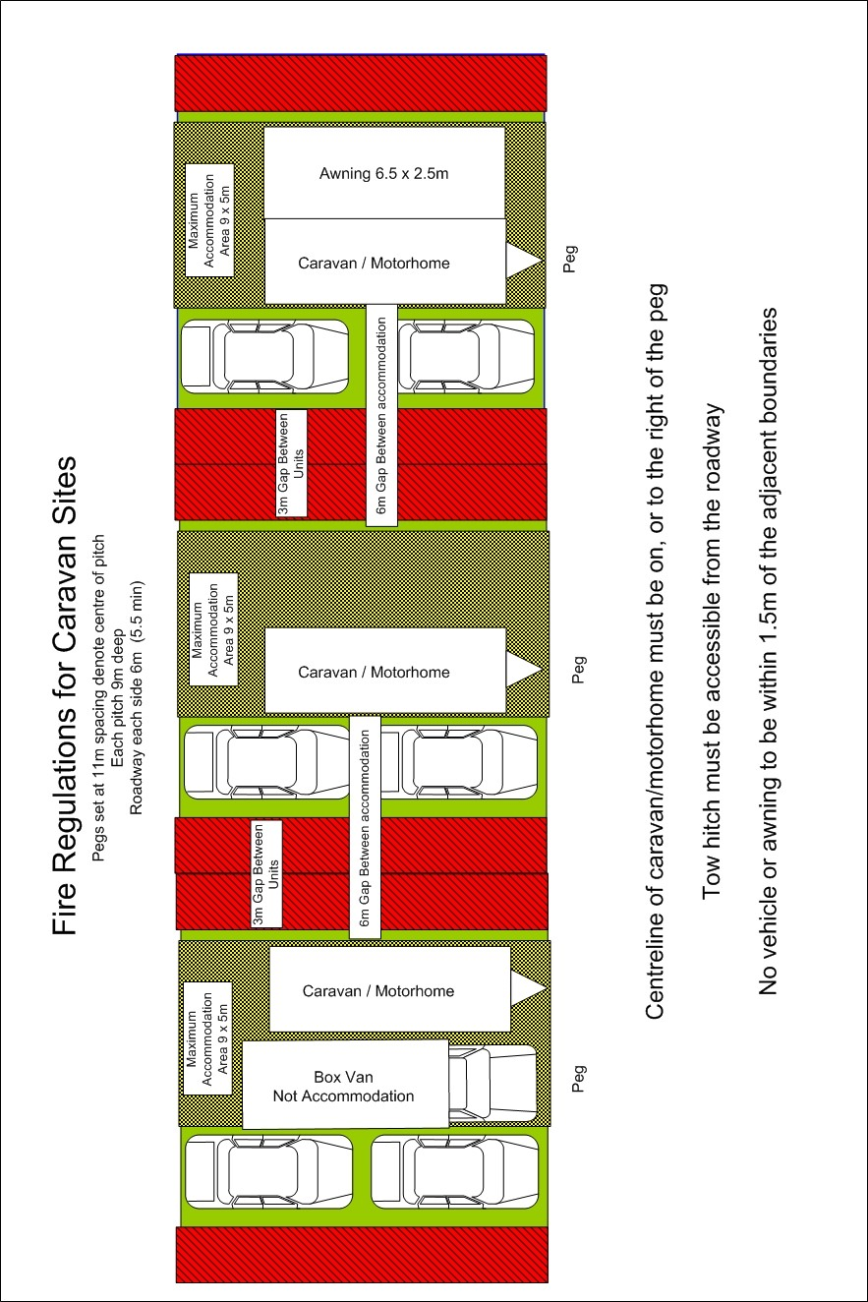

This page intentionally left blank

REMPSTONE STEAM & COUNTRY SHOW
11th and 12th July 2020
PUBLIC CARAVAN AND CAMPING BOOKING FORM

Please complete 1 Booking Form per Pitch, specifying the required details below. Please complete ALL the YELLOW boxes, and the BLUE boxes if applicable.
 | Number | Cost
Weekend pitch fee – Covers up to 4 nights and up to 2 Adults, accompanied children FREE :-  - £55.00 if booking received before Thursday 18th June 2020. | ONE
Each additional Adult (N.B. Weekend pitch fee includes up to 2 Adults) :-
- £16.00 if booking received before Thursday 18th June 2020.
TOTAL DUE
Single night rates available on request.
Full Name : |  |  |  |  |  |  | Disabled Pitch Required :- | YES / NO
Address :-
Postcode :- |  |  | E-mail :-
Home Telephone No. :- |  |  |  |  | Mobile No. :-

Please state Day and Approx. Time of Arrival (NO ARRIVALS BEFORE 15:00 on Thursday, or after 21:00 on Thursday or before 10:00 or after 21:00 on other days unless by prior arrangement).
Arrival Day :- | Thu 09-Jul -2020 / Fri 10-Jul-2020 / Sat 11-Jul-2020 |  |  |  |  |  |  |  |  | Approx. Arrival Time :-
No. of Nights :- |  |  |  |  | Total No. of Adults :- |  |  |  |  |  |  |  |  | Total No. of Children :
Type of Unit :- |  | CARAVAN / MOTORHOME / CAMPERVAN / TENT |  |  |  |  |  |  |  |  | Approx. Length :-
1st Vehicle Registration :- |  |  |  |  |  |  |  | No. of Adults in Vehicle :- |  |  |  |  |  |  | No. of Children in Vehicle :-
2nd Vehicle Registration :- |  |  |  |  |  |  |  | No. of Adults in Vehicle :- |  |  |  |  |  |  | No. of Children in Vehicle :-
Group Booking Name, if applicable :- |  |  |  |  |  |  |  |  |  |  |  | Expected Number of Pitches in Group :-
Any additional requirements (Please specify) :-

Where did you hear about us?
❏ | Website | ❏ | Facebook | ❏ | Twitter
❏ | Regular Attendee | ❏ | NTET Rally List | ❏ | Bus Advert
❏ | Newspaper Advert.  Which Newspaper? | ❏ | Magazine Advert  Which Magazine? | ❏ | Other  Please State

PTO and complete overleaf. Booking not valid if not signed.

Rempstone Traction Engine Club (RTEC) will hold your data solely for the purpose of contacting you in respect of your present and future attendance at the show. RTEC will not share your data with any third party or contact you other than in reference to the show.
I confirm that the information supplied above is correct and that I have read the “Terms and Conditions” and agree to adhere to them.
Signed :- |  | Date :-

- For booking by post please send :-
  - a completed Booking Form.
  - your remittance. Cheques should be made payable to Rempstone Traction Engine Club.
  - 2 (two) Stamped self-addressed Envelopes. The first envelope is for an acknowledgement of receipt of booking (of size either DL (110 x 220 mm.) or C5 (229 x 162 mm.)), the second is for sending out maps, arrival details, passes, etc. approximately 3-4 weeks before the show (of size C5 (229 x 162 mm.)).
to :- Rempstone Steam and Country Show, c/o Alan A Holmes, 11, Ellesmere Avenue, Wilmorton, Derby, DE24 8WD
- For booking by e-mail and bank transfer :-
  - please e-mail an electric copy of the completed Booking Form, either a copy of the completed Booking Form file or a scan or photograph of the completed Booking Form, to rempstonecaravansite@gmail.com.
  - if the completed Booking .Form is acceptable we’ll then e-mail a Booking Number and details of how to make the Bank Transfer.

