REMPSTONE STEAM & COUNTRY SHOW

13th & 14th July 2019

PUBLIC CARAVAN & CAMPING BOOKING DETAILS

PRICES
Public Caravan & Camping prices follow the simplified structure introduced in 2015 and consist of a single fee. The weekend pitch fee covers up to 4 nights (Thursday 12th, Friday 13th, Saturday 14th and Sunday 15th) for up to 2 Adults, accompanied children are FREE. Additional Adults will be charged at weekend prices.
N.B. Adults = 16 years and above, Children = 5 years – 15 years, Under 5 years Free.
N.B. New for 2019 is that bookings may also be made electronically.
Prices are as follows :-
- Standard Pre- Bookings – Bookings received on/after Thursday 20th June 2019 and before 12:00 on Thursday 11 July 2019 - Guaranteed a pitch once booking accepted. Bookings can ONLY be made electronically, please contact rempstonecaravansite@gmail.com for details of how to send the completed Booking Form and make the payment by Bank Transfer :-
  - £65.00 – Weekend pitch fee - Covers up to 4 nights for up to 2 Adults, accompanied children FREE. This covers admission to the Show on both days.
  - £20.00 – Weekend price for each additional Adult. This covers admission to the Show on both days.
  - Single night rates are available on request.
- Pay on Arrival – Not guaranteed a pitch, available ONLY if pitches are available :-
  - £65.00 – Weekend pitch fee - Covers up to 4 nights for up to 2 Adults, accompanied children FREE. This covers admission to the Show on both days.
  - £20.00 – Weekend price for each additional Adult. This covers admission to the Show on both days.
  - Single night rates are available on request.
Please complete separate Booking Forms for each Pitch required.
N.B. Although accompanied children are FREE we still need to know how many will be arriving, so that we can arrange for the necessary passes etc..

TERMS & CONDITIONS
- General
  - Staying on the Public Caravan & Camping site gives you unlimited access to the show and entertainment.
  - The Rempstone Traction Engine Club Committee reserves the right, and empowers Stewards, to refuse entry to or expel anyone who behaves in an anti-social manner or damages property.
  - If you wish to have several pitches sited together then a Group Booking is required. Group Bookings are acceptable for Pre-Bookings. Please fill in individual Booking Forms completing the “Group Booking Name” and “Expected Number of Pitches in Group” fields and we will arrange to site together.
N.B. Group Bookings CANNOT be guaranteed for “Pay on Arrival”.
  - Please complete separate Booking Forms for each Pitch required.
- Arrival and Departure
  - No arrivals before 15:00 on Thursday 11th July 2019.
  - No arrivals after 21:00 on Thursday 11th July 2019, unless by prior arrangement.
  - No arrivals before 10:00 or after 21:00 on Friday 12th July 2019 and Saturday 13th July 2019, unless by prior arrangement.
  - All Caravans and Campers MUST leave site by 12:00 on Monday 15th July 2019.
- Site
  - The Rally site is farmland which is mainly grassed and can be uneven and slippery. Please take care and ensure you wear suitable footwear for this type of surface.
- Pitches
N.B. See “Fire Regulations for Caravan Sites” on page 4, in conjunction with the terms below.
  - Pitches for Pre-Bookings will be pre-allocated at time of acceptance of booking.
  - Pitches will be 11 m. wide and 9 m. deep.
  - Centre line of the caravan/motorhome/campervan must be on the centre line of the pitch or to the right of the centre line if there is no awning.
  - Tow hitch must be accessible from the roadway at all times, no exceptions. Continental caravans with no awning can be parked in the same direction as other caravans; those with an awning can be parked the other way around with the tow hitch on the roadway at the rear.
  - Tents should have their cooking area as close to the centre line of the pitch as possible.
  - Nothing is allowed in the 1.5 m. strip at the edge of each pitch, thus giving a 3 m. gap between units.
  - There must be a 6 m. gap between adjacent accommodation (caravan, motorhome, campervan, awnings, tents).
  - Awnings are allowed. For safety reasons awnings must not face each other.
  - Vehicles may be parked between accommodation, provided that the 3 m. gap between units is left clear and there is the 6 m. gap between adjacent accommodation.
N.B. If a second vehicle is required, because of the total number of adults and children or because of different arrival times of the occupants, this is allowed at no extra cost provided both vehicles can be accommodated within the pitch length. Please specify both registration numbers on the Booking Form along with the number of adults and children arriving in each vehicle to allow passes to be produced for both vehicles.
  - We have a small number of Disabled pitches adjacent to the Show Fields. These are allocated on a first come first served basis.
- Safety, Security and Comfort
  - There is a 5 m.p.h. speed restriction on site, which MUST be adhered to at all times. The exceptions will be any emergency services, security and occasionally show service vehicles.
  - All drivers must hold a full driving licence for the type of vehicle being driven.
  - Motorised trikes and quad bikes must NOT be used. The exceptions will be any emergency services, security and occasionally show service vehicles.
  - The gates will be locked between 23:00 and 07:00.
  - Vehicle movement on site is prohibited between 23:00 and 07:00.
  - Noise should be kept to a minimum between 23:00 and 07:00.
  - Generators may be used, at the discretion of the site stewards, between 09:00 and 21:00. Please ensure that fuel is stored in approved and marked containers, that exhausts do not annoy adjoining pitches, and that all necessary safety precautions are taken with connections.
- Payments
  - Payment for Pre-Bookings made by post MUST be made at the time of booking, to guarantee pitches. Cheques should be made payable to Rempstone Traction Engine Club.
  - Payment for Pre-Bookings made online MUST be made at the time of booking.
  - Payment for Pay on Arrival MUST be made in cash on arrival.
- Visitors
  - If you have visitors they will be asked to park near to the entrance gate of the Public Caravan & Camping field, to minimise vehicle movement on site. For those with mobility issues a limited amount of parking will be available near the entrance to the Show Fields.
  - Visitors will be charged the daily entrance fee (£10.00 per Adult per day, accompanied children FREE) to access the Show.
- Water, Sanitation and Rubbish
  - Fresh drinking water will be available from several locations around the site. Please ensure taps are fully turned off after use.
  - Taps designated as drinking water MUST NOT be used for any other purpose, i.e. washing hands or cleaning chemical toilets.
  - Chemical toilets MUST only be emptied in the chemical disposal tanks which will be located around the site.
  - Grey water may be disposed of on the ground, following sensible precautions.
  - Toilet facilities will be available from the afternoon of Thursday 11th July 2019 until 09:00 on Monday 15th July 2019.
N.B. There will only be limited toilet facilities available from the evening of Sunday 14th July 2019 until 09:00 on Monday 15th July 2019.
  - Please do NOT use toilets for emptying chemical waste or grey water.
  - Please take your rubbish home as we have to pay to dispose of all rubbish left on the site and this reduces the amount we are able to donate to charity. If in exceptional circumstances you are unable to take your rubbish home, please place it in one of the bins provided. If your nearest bin is full please find another as waste left on the ground encourages vermin and increases our clean-up costs.
- Barbeques and Campfires
  - Only gas or charcoal barbeques are allowed. Barbeques should be placed on a suitable stand and not directly on the grass.
  - Please ensure that the ground does not get damaged.
  - Campfires are NOT permitted.
- Pets
  - Pets are welcome on site but you are responsible for the behaviour of your animals.
  - Please ensure that your animals are not allowed loose on site and are kept on a lead no longer than 2 metres, no exceptions.
  - Pets must not be left in an unattended vehicle. Rempstone Traction Engine Club reserve the right to forcibly enter a vehicle should we observe and believe that an animal is in distress and the authorities will be informed.
  - Any fouling must be cleaned up and disposed of in the waste bins or skips.

GENERAL DATA PROTECTION REGULATION – PRIVACY POLICY
Rempstone Traction Engine Club (RTEC) will hold your data solely for the purpose of contacting you in respect of your present and future attendance at the show. RTEC will not share your data with any third party or contact you other than in reference to the show.

FURTHER INFORMATION
Further information is available from :-
Rempstone Steam and Country Show
c/o 11, Ellesmere Avenue
Wilmorton
Derby
DE24 8WD
Contact Name : Alan Holmes
E-mail: rempstonecaravansite@gmail.com
Mobile No.: 07583 678459 (N.B. This number is for Caravan &Camping Enquiries ONLY.)
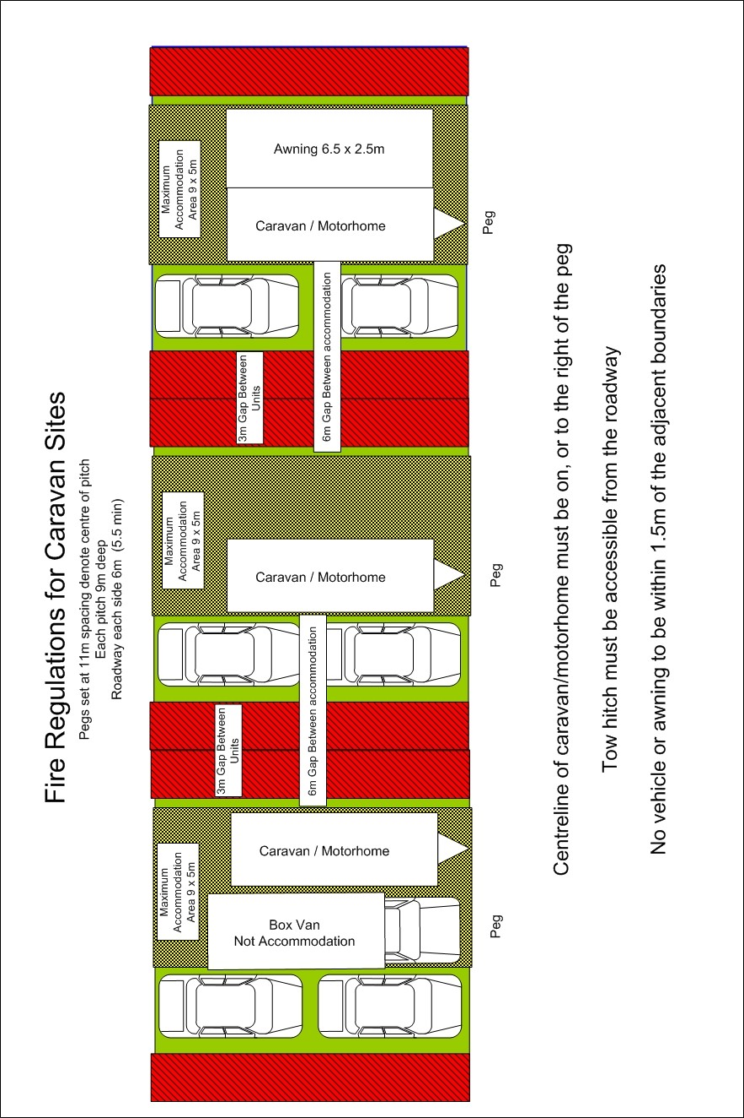

This page intentionally left blank

REMPSTONE STEAM & COUNTRY SHOW
13th & 14th July 2019
PUBLIC CARAVAN & CAMPING BOOKING FORM

Please complete 1 Booking Form per Pitch, specifying the required details below. Please complete ALL the YELLOW boxes, and the BLUE boxes if applicable.
 | Number | Cost
Weekend pitch fee – Covers up to 4 nights and up to 2 Adults, accompanied children FREE :-  - £65.00 if booking received on/after Thursday 20th June 2019 and before 12:00 on Thursday 11 July 2019. | ONE
Each additional Adult (N.B. Weekend pitch fee includes up to 2 Adults) :-
- £20.00 if booking received on/after Thursday 20th June 2019 and before 12:00 on Thursday 11 July 2019.
TOTAL DUE
Single night rates available on request.
Full Name : |  |  |  |  |  |  | Disabled Pitch Required :- | YES / NO
Address :-
Postcode :- |  |  | E-mail :-
Home Telephone No. :- |  |  |  |  | Mobile No. :-

Please state Day and Approx. Time of Arrival (NO ARRIVALS BEFORE 15:00 on Thursday, or after 21:00 on Thursday or before 10:00 or after 21:00 on other days unless by prior arrangement).
Arrival Day :- | Thu 11-Jul -2019 / Fri 12-Jul-2019 / Sat 13-Jul-2019 |  |  |  |  |  |  |  |  | Approx. Arrival Time :-
No. of Nights :- |  |  |  |  | Total No. of Adults :- |  |  |  |  |  |  |  |  | Total No. of Children :
Type of Unit :- |  | CARAVAN / MOTORHOME / CAMPERVAN / TENT |  |  |  |  |  |  |  |  | Approx. Length :-
1st Vehicle Registration :- |  |  |  |  |  |  |  | No. of Adults in Vehicle :- |  |  |  |  |  |  | No. of Children in Vehicle :-
2nd Vehicle Registration :- |  |  |  |  |  |  |  | No. of Adults in Vehicle :- |  |  |  |  |  |  | No. of Children in Vehicle :-
Group Booking Name, if applicable :- |  |  |  |  |  |  |  |  |  |  |  | Expected Number of Pitches in Group :-
Any additional requirements (Please specify) :-

Where did you hear about us?
❏ | Website | ❏ | Facebook | ❏ | Twitter
❏ | Regular Attendee | ❏ | NTET Rally List | ❏ | Bus Advert
❏ | Newspaper Advert.  Which Newspaper? | ❏ | Magazine Advert  Which Magazine? | ❏ | Other  Please State

PTO and complete overleaf. Booking not valid if not signed.

Rempstone Traction Engine Club (RTEC) will hold your data solely for the purpose of contacting you in respect of your present and future attendance at the show. RTEC will not share your data with any third party or contact you other than in reference to the show.
I confirm that the information supplied above is correct and that I have read the “Terms & Conditions” and agree to adhere to them.
Signed :- |  | Date :-

Bookings can ONLY be made electronically, please contact rempstonecaravansite@gmail.com for details of how to send the completed Booking Form and make the payment by Bank Transfer.

